**Name1: Alley Student Number1: 301194572**

1. What is TDD? (1)

TDD is a test first approach in software development. First you write a test write then you write enough code to fulfill that test then you refactor.

1. What is the process followed by TDD? Explain with a diagram. (2)

Develop one test first then develop the code for that test to be able to execute the test. If code passes test add another test. If test fails, then correct the code and run the test again.

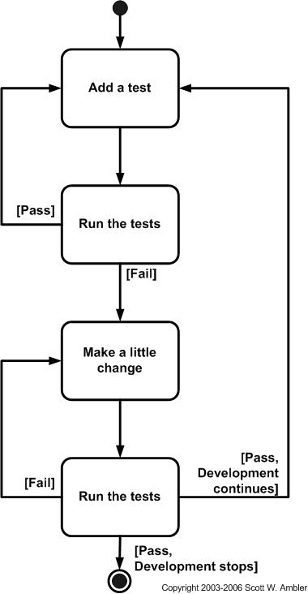

1. Read the criticism of TDD laid out in the following article: <http://dalkescientific.com/writings/diary/archive/2009/12/29/problems_with_tdd.html>.

Discuss the conclusions of the article (in less than half a page). If you disagree in your opinions, please say so. (5)

I disagree with the conclusion from the author because I believe that TDD upholds good testing practices. I don’t see how TDD excludes import tests in the development phrase when there is a census that TDD can have a test for every feature, which makes it high coverage. The first quote they even used stated that TDD seems to improve software quality and at worst it doesn’t quality stays the same.

The author seems to constantly say that even without TDD results would be the same but that doesn’t mean there is a problem with TDD as a whole. My understanding of TDD is that it can slow down the process, but I think that it’s worth it to produce better quality in this give and take scenario.

1. Give the Screenshot displaying all the three tests running successfully in Visual studio as instructed in the A3_TDD_Instruction.pdf. (Individual Submission) (2)

